|  |  |  |
| --- | --- | --- |
| **FOCUS** | CHEMISTRY | |
| **KNOWLEDGE AREA** | MATTER AND MATERIALS | |
| **TOPIC** | 3 | Organic molecules |
| **SUBTOPIC** | 3.2 | IUPAC naming and formulae |
| **NAME OF ASSET** | 3.2.1 | Build organic molecules |

|  |  |
| --- | --- |
| **TYPE OF ASSET** | SIMULATION: Model |
| **SUBTYPE** | 1S1A |
| **OBJECTIVE** | Use drag-and-drop to build organic molecules from their IUPAC names |

**SUBHEADING:** Build the molecule from the IUPAC name.

**TEXT FOR BUTTONS**

**Instructions**

1. The IUPAC name of an organic compound appears on the screen.
2. Use the atoms given in the side strip to build one molecule of the given compound.
3. Drag the atoms into the grey square.
4. Connect the atoms by dragging single bonds or double bonds between them.
5. Click on the CHECK button to see whether you were correct.

**Check**

* Green tick for correct answer and red cross for incorrect answer next to the model.
* If answer correct: Immediately change arrangement to the correct ball-and-stick model, as far as possible adhering to VSEPR theory. Message: Correct!
* Next button appears that brings up the next molecular compound.
* If answer incorrect: Incorrect [Try again button appears] [Reveal answer button appears]

**USER INTERACTION**

* This is similar to the new simulation that was written for Gr 10 Physical Sciences: “1.3.1 Determine the correct formulae for compounds”.
* IUPAC name of organic compound at the top of the screen. Load in random order:

|  |
| --- |
| pent-2-ene |
| methylpropane |
| 2-methylbut-1-ene |
| ethyl methanoate |
| 2,3-butanediol |
| 1,1,2-trichloropropane |
| butan-2-one |
| ethanoic acid |
| tetrachloromethane |
| 2-methylpropanal |

* Provide the following atoms and bonds in a side strip. As far as possible, use correct CPK colours and relative sizes. Make sure the bonding lines are all the same length.

|  |
| --- |
| **H** |
| **C** |
| **O** |
| **Cl** |
| **║** |
| **│** |
| **―** |
| **═** |
|  |
|  |
|  |
|  |

* Supply a grey square as the building area.
* User must drag the correct atoms into the building area, with a single or double bond between every two atoms where applicable. The atom and bond tiles are reusable, i.e. when one is dragged, there is another present behind it.
* Note the exact positions of the atoms are not so important **but there must be overlap to** **denote** **covalent bonding.**
* There are several possible correct answers for each molecule. In addition, the
* When the user drags an atom or bond tile that is already in the building area, out of the area and releases it, it should go back to its correct position on the stage.
* When user hovers over any of the atoms or bonds either on the stage or already placed in the grey building area, give mouseover (hand symbol instead of mouse pointer) for mouse-based devices.
* When user clicks CHECK button and the answer is correct, automatically rearrange to the correct ball-and-stick model, as far as possible adhering to VSEPR theory.

**ANSWER KEY**

**pent-2-ene**

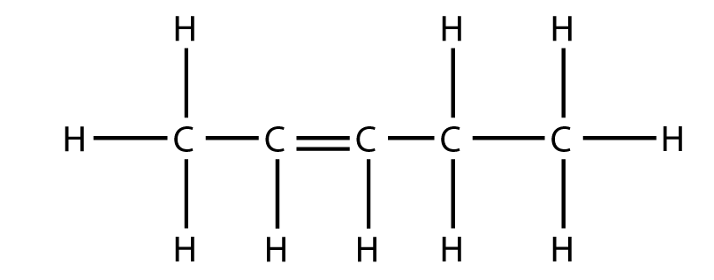

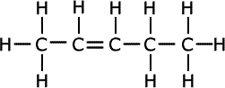 and 10 more variants:

**methylpropane**

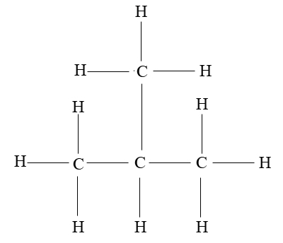**

**2-methylbut-1-ene**

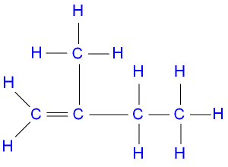 and 3 variants:

**ethyl methanoate**

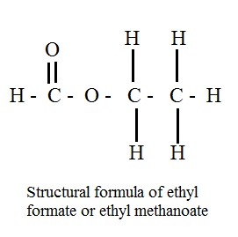and 5 variants:

**2,3-butanediol**

and 3 variants:

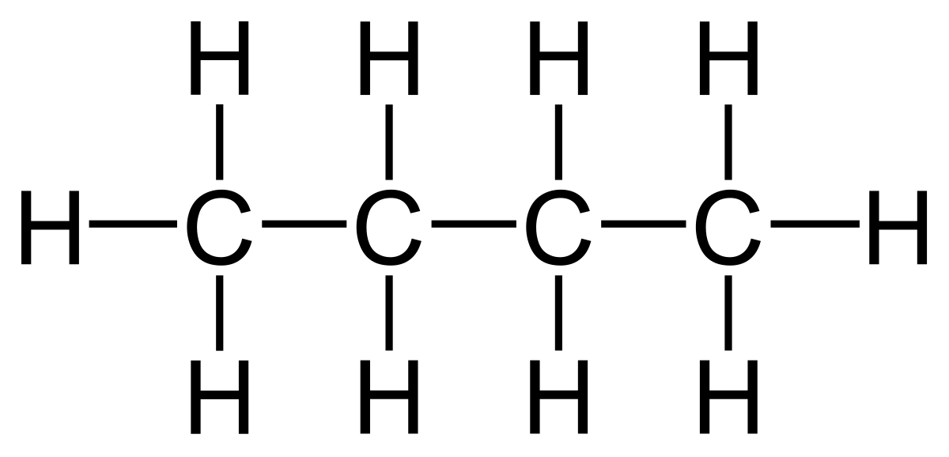

O

O



**1,1,2-trichloropropane**

and 11 variants:

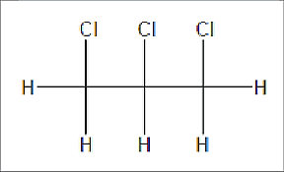

C

C

C

Cl

H

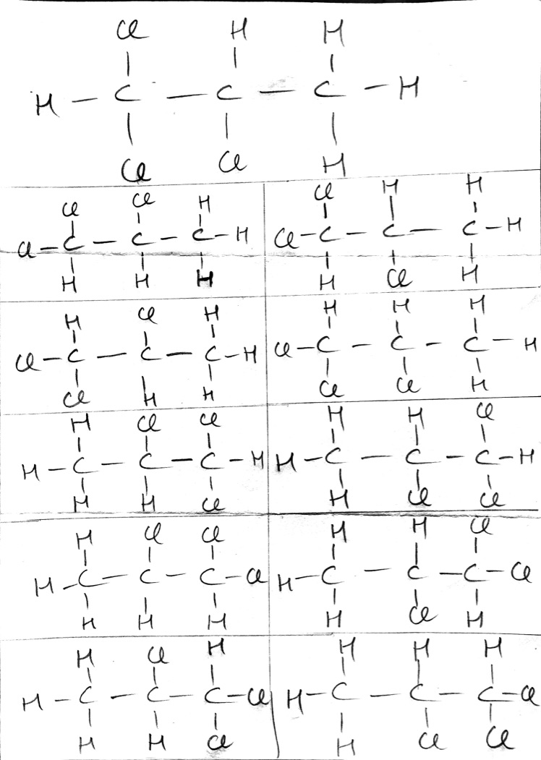

**butan-2-one**

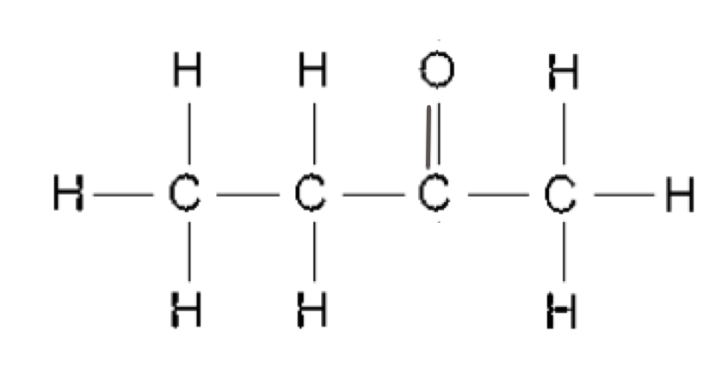 and 15 variants:

**ethanoic acid**

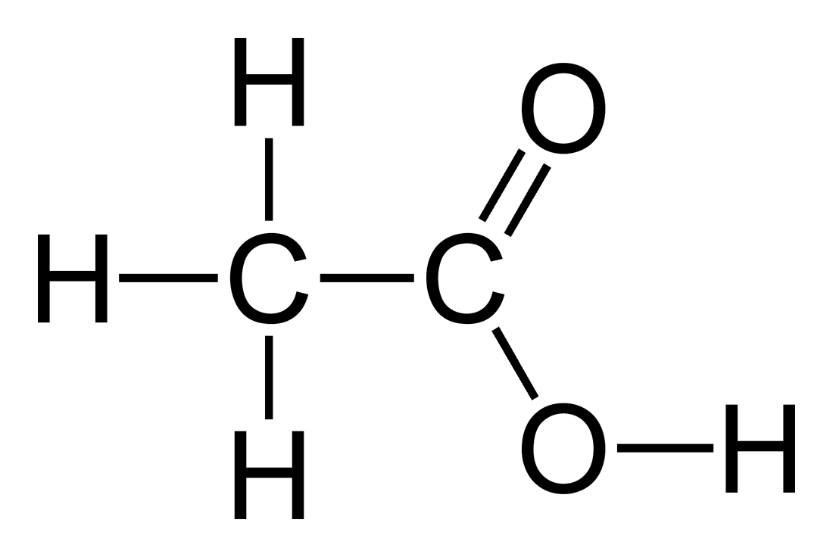and 15 variants:

**tetrachloromethane**

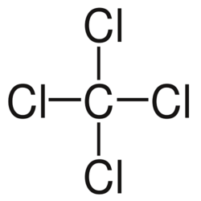

**2-methylpropanal**

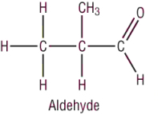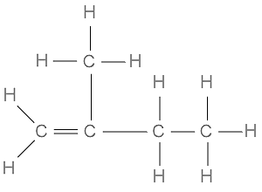

and 31 variants:

